**LIT ASSIGNMENT -DAY 10**

**EMPLOYEE ID – 46255260**

**Assignment 3 – Business Add in (BADI)-Single Use.'**

* Define a BADI (ZBADI_DEMO_01…05) in SE18.

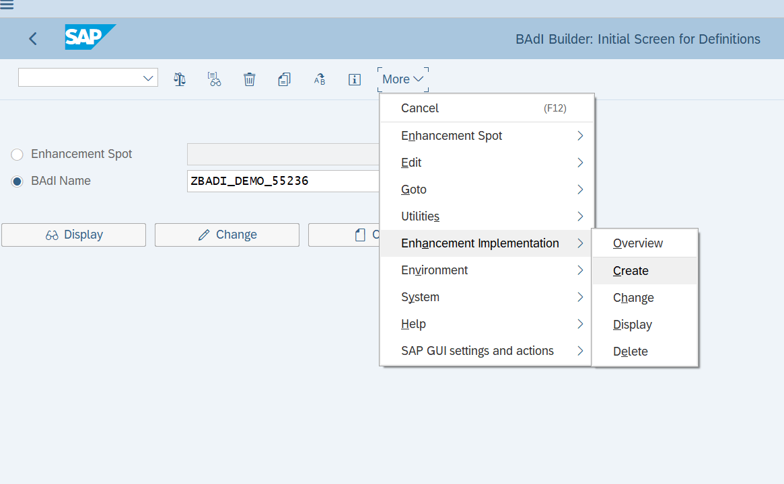    
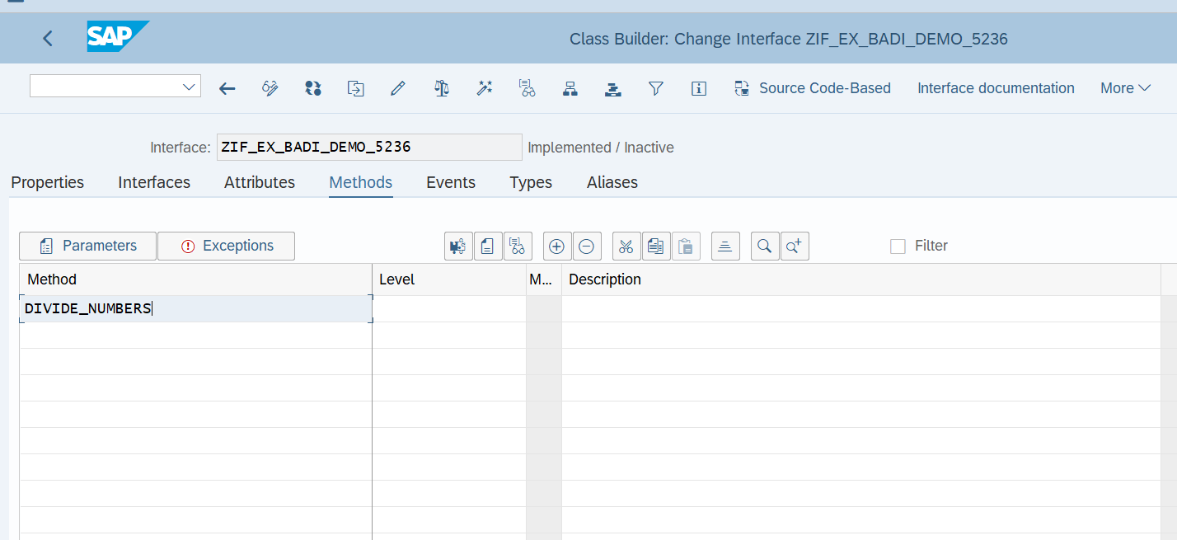    
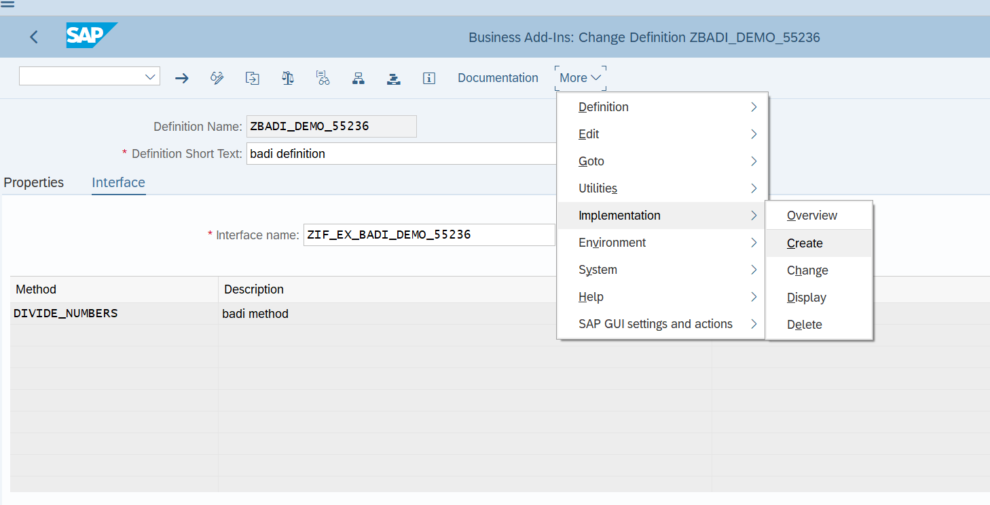    
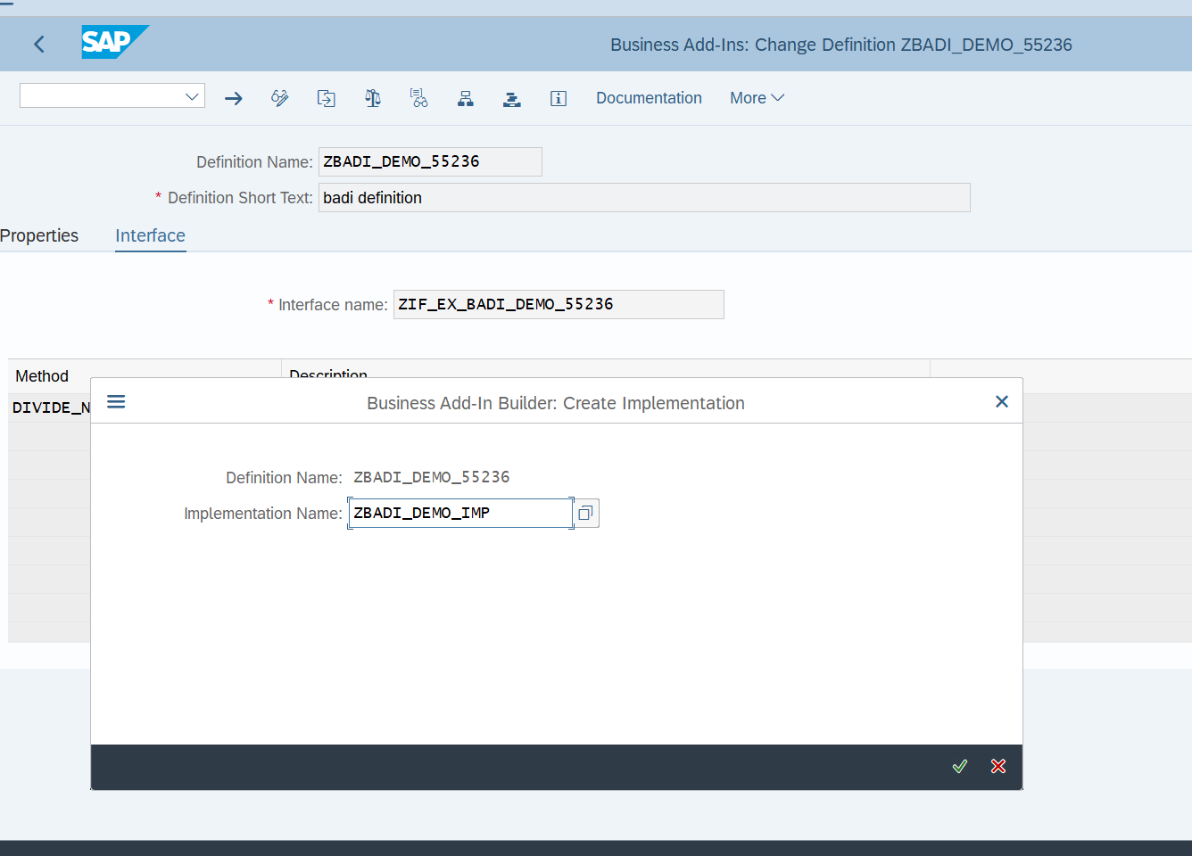    
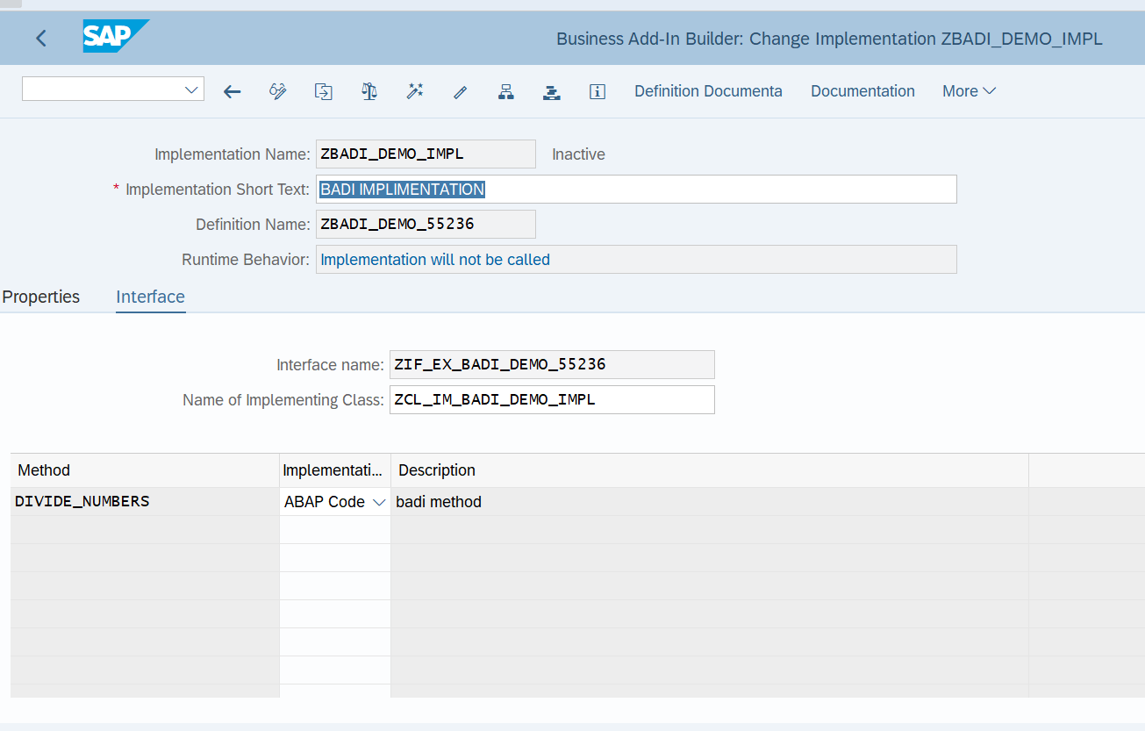    
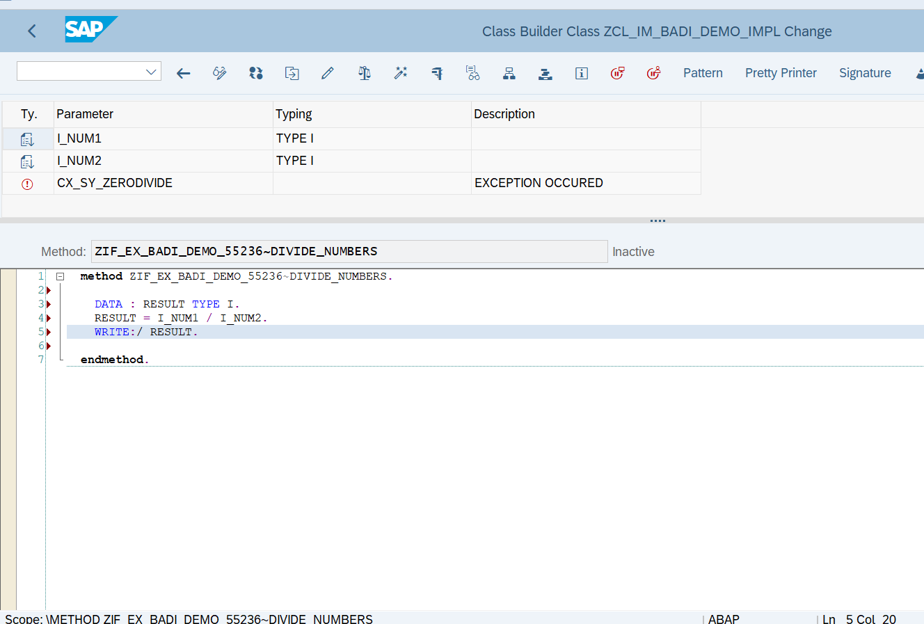    
REPORT Z415_BADI_DEMO.     
     
START-OF-SELECTION. CLASS CL_EXITHANDLER DEFINITION LOAD.     
DATA: RESULT TYPE I.     
DATA OBJ1 TYPE REF TO ZIF_EX_BADI_DEMO_55236.     
     
PARAMETERS: NUM1 TYPE I,     
            NUM2 TYPE I.     
     
CALL METHOD cl_exithandler=>get_instance     
  EXPORTING     
    exit_name                     =  'ZBADI_DEMO_55236'     
*\*    null_instance_accepted        = SEEX_FALSE*     
*\*  IMPORTING*     
*\*    act_imp_existing              =*     
  CHANGING     
    instance                      = OBJ1     
  EXCEPTIONS     
    no_reference                  = 1     
    no_interface_reference        = 2     
    no_exit_interface             = 3     
    class_not_implement_interface = 4     
    single_exit_multiply_active   = 5     
    cast_error                    = 6     
    exit_not_existing             = 7     
    data_incons_in_exit_managem   = 8     
    others                        = 9     
        .     
IF sy-subrc <> 0.     
*\* Implement suitable error handling here*     
ENDIF.     
     
TRY.     
  CALL METHOD obj1->divide_numbers     
      EXPORTING i_num1 = NUM1     
                i_num2 = NUM2 .     
 CATCH cx_sy_zerodivide .     
        
   ENDTRY.

OUTPUT:

Page Break

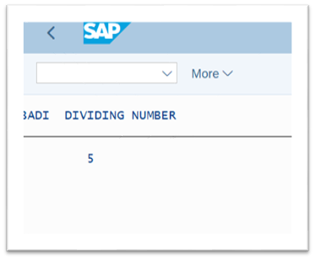  
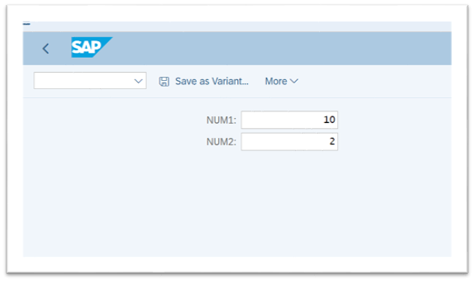  
  
**Assignment 4 – Business Add in (BADI)-Multiple Use**

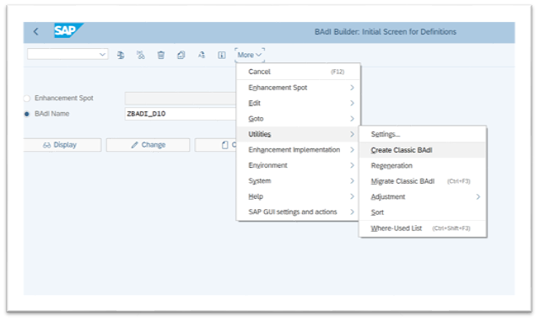

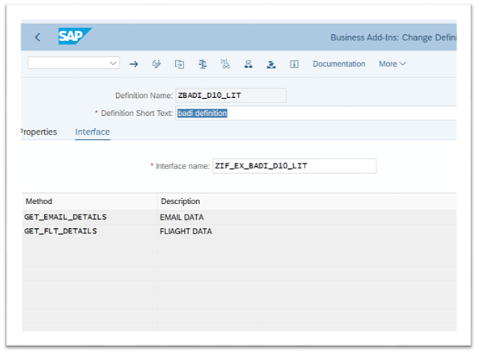

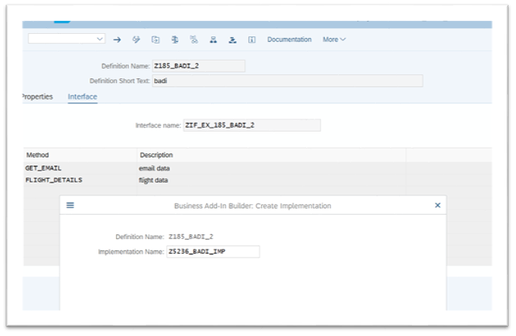

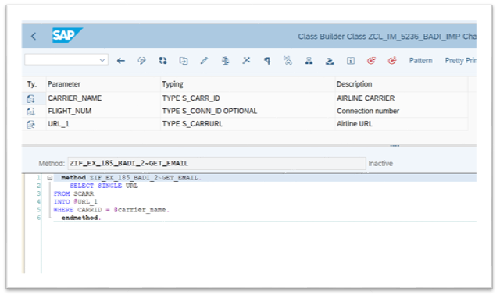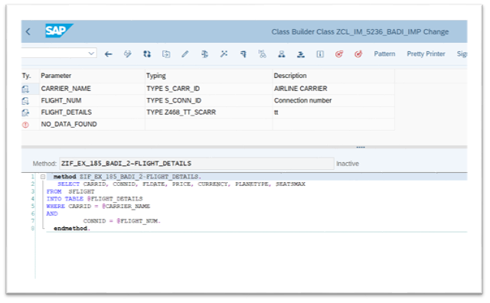

REPORT Z415D10.     
     
DATA: OBJ TYPE REF TO ZIF_EX_BADI_D10_LIT.     
     
PARAMETERS: p_carr TYPE S_CARR_ID,     
            P_flight TYPE S_CONN_ID.     
     
     
DATA : it_flight TYPE  Z468_TT_SCARR,                          *" declaring internal table of sflight*     
       gs_sflight TYPE line of Z468_TT_SCARR,     
       url type s_carrurl.     
CL_EXITHANDLER=>GET_INSTANCE(     
EXPORTING     
    EXIT_NAME                     =  'ZBADI_D10_LIT'   *" Business Add-In Definition*     
*\*    NULL_INSTANCE_ACCEPTED        =     " Is Null Instance OK if There Is no Active Implementation?*     
*\*  IMPORTING*     
*\*    ACT_IMP_EXISTING              =     " Returns an Active Implementation*     
CHANGING     
    INSTANCE                      =  OBJ   *" Instance*     
EXCEPTIONS     
    NO_REFERENCE                  = 1     
    NO_INTERFACE_REFERENCE        = 2     
    NO_EXIT_INTERFACE             = 3     
    CLASS_NOT_IMPLEMENT_INTERFACE = 4     
    SINGLE_EXIT_MULTIPLY_ACTIVE   = 5     
    CAST_ERROR                    = 6     
    EXIT_NOT_EXISTING             = 7     
    DATA_INCONS_IN_EXIT_MANAGEM   = 8     
OTHERS                        = 9     
).     
IF SY-SUBRC <> 0.     
*\* MESSAGE ID SY-MSGID TYPE SY-MSGTY NUMBER SY-MSGNO*     
*\*            WITH SY-MSGV1 SY-MSGV2 SY-MSGV3 SY-MSGV4.*     
ENDIF.     
     
CALL METHOD obj->get_flt_details     
  EXPORTING     
    carrier_name   = p_carr     
    flight_num     = p_flight     
  CHANGING     
    flight_details = it_flight     
*\*  EXCEPTIONS*     
*\*    no_data_found  = 1*     
*\*    others         = 2*     
        .     
IF sy-subrc <> 0.     
*\* Implement suitable error handling here*     
ENDIF.     
     
     
     
     
     
CALL METHOD obj->get_email_details     
  EXPORTING     
    carrier_name = p_carr     
    flight_num   = p_flight     
  CHANGING     
    url          = url     
    .     
     
     
     
WRITE: / 'Airline URL is' COLOR COL_POSITIVE,  url.     
WRITE: 40 'Flight Details' COLOR COL_POSITIVE.     
WRITE: / 'CARRID',     
10 'CONNID',     
20 'FLDATE',     
31 '      PRICE',     
52 'CURRENCY',     
63 'PLANETYPE',     
75 'SEATSMAX'.     
ULINE.     
LOOP AT it_flight INTO gs_sflight.     
WRITE : /  gs_sflight-carrid LEFT-JUSTIFIED,     
10 gs_sflight-connid,     
20 gs_sflight-fldate,     
31 gs_sflight-price,     
52 gs_sflight-currency,     
63 gs_sflight-planetype,     
75 gs_sflight-seatsmax.     
ENDLOOP.

